Thème : Comment analyser et expliquer les inégalités ?

SUBJECT : What are the risks of youth unemployment ?

Document : The jobless generation

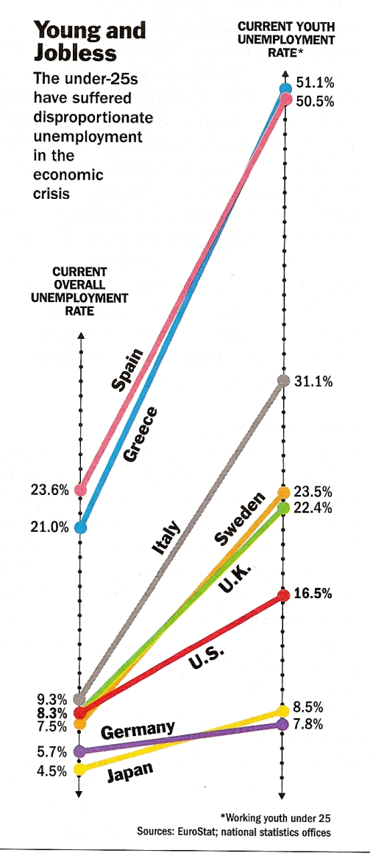

Creating jobs for the up-and-coming generation has become one of the most urgent problems facing policymakers worldwide. From Milan to Manila, Seattle to Santiago, the global economy is failing to provide good job opportunities for college graduates and others entering the workforce for the first time. […] The longer the youth crisis persists, the more severe the consequences will be for the global economy […]. Instead of nurturing the labor force of the future, the world is creating an underclass of millions of disaffected workers who lack the skills necessary to support growth for decades to come. For advanced economies, where high costs make the development of top-notch talent even more critical, the damage to competitiveness could hamper these countries’ ability to contend with emerging rivals like China and India. In an aging society, especially in Europe and Japan, youth unemployment makes the burden of funding health care and pensions for retirees even heavier, since the number of taxpaying workers is curtailed and the cost of benefits that governments must provide increases. That puts some more strain on government already buried under debt.

Source : Michael SCHUMAN, Time, April 16, 2012

- What are the reasons why young people find no jobs?

- What links can you make between youth unemployment and the economic crisis?

- What would be the consequences if young people were not able to find jobs that correspond to their skills?

Disaffected : disillusionned
Top-notch : first class
Hamper : restrict
Curtailed : decreased

