ACTIVITÉ 1 : COMPREHENSION ECRITE

- Regardez l’illustration et le titre de cet article sur internet. Quel en est le sujet ?

Finnish Nightmares – A Different Kind of Social Guide To Finland

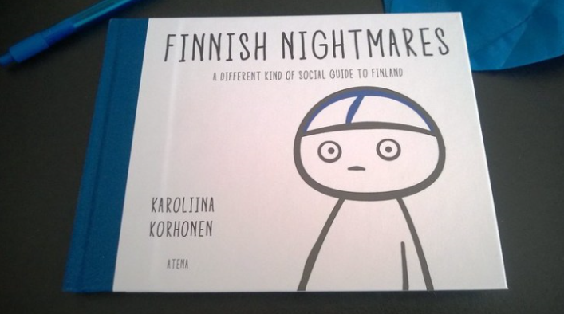

Pays: ............................................................................
Adjectif pour désigner la nationalité de ce pays : ..........................................................................
Genre de publication: .........................................................................................
Auteur: ............................................................................................................
Sujet: ...........................................................................................................

- Lisez le début de l’article. Qu’est-ce qui est difficile pour certaines personnes :
“Finnish Nightmares – A Different Kind of Social Guide to Finland by Karoliina Korhonen is series of comic strips. They describe situations in which Finns feel awkward. Usually it involves human interaction.”

............................................................................................................................................................................................
............................................................................................................................................................................................
- Quel dessin associeriez-vous à ces situations d’interaction sociale ? Écrivez le numéro correspondant. Imaginez une situation similaire et dessinez-la pour le prochain cours :

When you are waiting for the bus to arrive in pouring rain, you can’t seek cover under bus stop’s shelter if there is someone already there. Because you respect the personal space of that person. As a result, you will be soaking wet.
When someone tries to greet you by hugging, you think it means more than that.

When someone tries to start a conversation with you, you just give very short answers.

When someone sits next to you in public transports, you feel so uncomfortable you just want to be somewhere else.

When you have to speak loudly to the bus driver because the button is broken. You know everybody will listen and they will look at you.

When you / someone

1
3

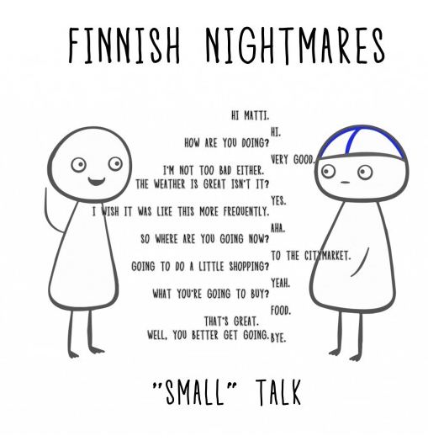
2
4
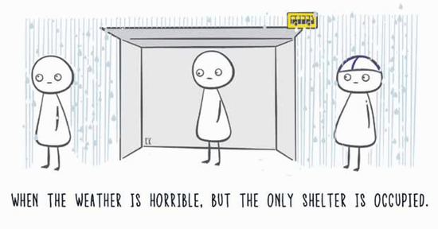
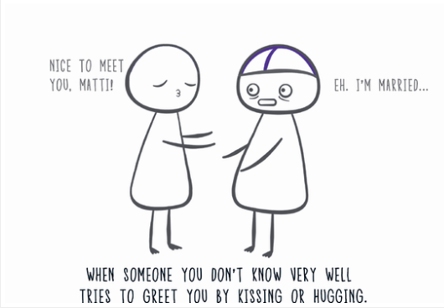
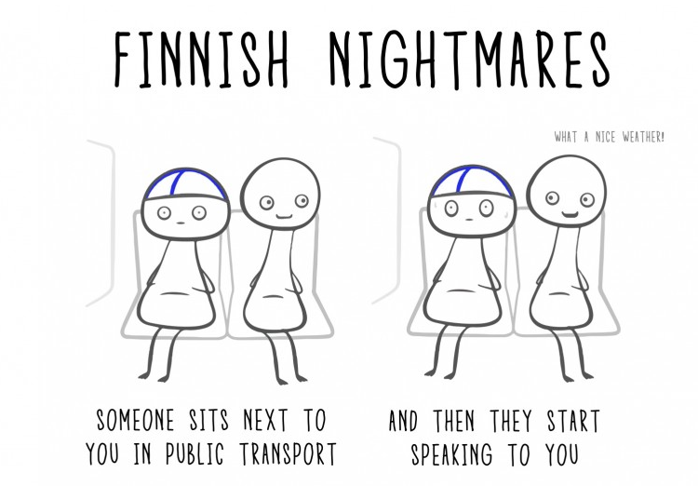
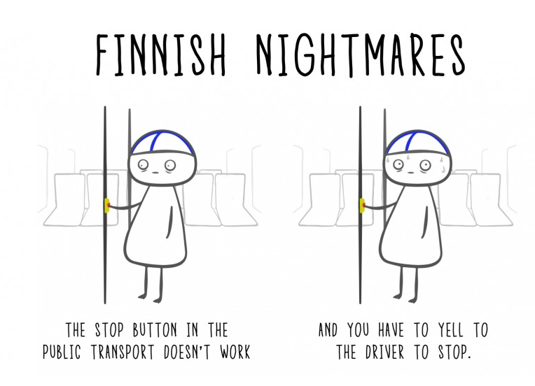
5

- Lisez maintenant ce texte :
American people love to talk with strangers; in that, they are very different from French or British people for example (not to mention Finnish!) who are much more reserved. American people start conversations in buses, planes and food or clothes shops – well in fact anywhere. In general, they are comely and silence may be very disturbing to them.
This sort of communication behavior, sometimes called small talk, is part of the American culture. Talking a lot, and sometimes talking a lot about nothing that seems to be very significant or important, is something that some internationals working in the US may find odd or strange.
https://www.englishwithimpact.com
Y-a-t-il une différence entre les américains et les finlandais en ce qui concerne les interactions sociales ?
………………………………………………………………………………………………………………………………………………………………………..…………………………………………………………………………………………………………………………………………………………………………………………………..
Si un ami partait travailler aux USA. Quel conseil lui donneriez-vous ?
........................................................................................................................................................................................................................................................................................................................................................................................

ACTIVITÉ 2 : EXPRESSION ORALE

- Parmi les questions suivantes, qu’elles sont celles que vous ne devriez pas poser si vous ne connaissez pas bien votre interlocuteur. Cochez-les. ☑

Do you speak English?
What’s your name?
Where are you from?
How old are you?
Are you married?
Are you pregnant?
Do you have children?
How old are you?
Why don’t you have children?
Where are you from?
What is the weather like in your country?
How much money do you make?
Where do you live?
What’s your address?
What’s your phone number?
How are your parents?
How is your husband?
Why are you divorced?
Why aren’t you married?
How old are your children now?
How much do you weigh?

- Reformulez les questions indélicates :

Do you mind if I ask ........................................................................................................................................................?
May I ask .........................................................................................................................................................................?
- Comment répondre de manière polie ? Cochez. ☑

Mind your own business.
I’d rather not say.
Do I ask you if....
Go away.
It’s personal.
It’s private.
It’s a secret.
Leave me alone.
- Role Play. Quel mot interrogatif faut-il employer ? Demandez à votre voisin de vous désigner la carte correspondante. Aidez si besoin en traduisant la question.
Posez les questions à votre voisin, adaptez-les à votre situation si cela est nécessaire et répondez à ses questions.

STUDENT A
1 -......... old are you?
how – quel âge avez-vous ?
2 -......... do you live?
where - où habitez-vous ?
3 -......... are you from?
where – d’où êtes-vous ?
4 -......... brothers and sisters have you got?
how many – combine de frères et de soeurs avez-vous ?
5 -......... is the weather like at home?
what – quel temps fait-il chez vous ?
6 -......... is it like in the summer?
what - quel temps fait-il l’été ?
7 -......... do you live exactly in Chicago?
where – où vivez-vous précisément à chicago ?
8 -......... did you arrive?
when – quand êtes-vous arrivé ?
9 -......... did you travel?
how – comment avez-vous voyage ?
10 -......... are you studying at the moment?
what – qu’étudiez-vous en ce moment ?

--------------------------------------------------------------------------------------------------------------------fold the page here -

STUDENT B
1 - ......... languages do you speak?
how many – combien de langues parlez-vous ?
2 - ......... have you been in that school?
how long - depuis combien de temps êtes-vous dans ce lycée ?
3 - ......... is your telephone number?
what – quel est votre numéro de téléphone ?
4 - ......... is your job?
what – quel est votre profession ?
5 - ......... are your children now?
how old – quel âge ont vos enfants maintenant ?
6 - ......... are your parents?
how - comment vont vos parents ?
7 - ......... does your family live?
where – où vit votre famille ?
8 - ......... did you take the train this morning?
what time– à quelle heure avez-vous pris le train ce matin ?
9 - ......... is your hotel from here?
how far – à quelle distance se trouve votre hôtel ?
10 - ......... is your boss?
who – qui est votre employeur ?

CHALLENGE 1 Parlez du temps (météo) pendant 2 minutes. Posez-vous les questions suivantes en utilisant la fiche outil. Lorsque c’est terminé recommencez en faisant un enregistrement et envoyez-le au professeur.

- It’s a beautiful / terrible day, isn’t it?
- It’s hot / cold today, isn’t it?
- Where do you come from? … Is it the same in the winter / summer?
- What was it like last weekend?
- What was it like during the holidays?
- Do you like this weather? … Why?
- And you?
- What will it be like this afternoon / this evening?
- Do you know what it will be like this weekend / these holidays / this summer?

CHALLENGE 2 5 minutes pour chaque élève. Fiche outil SMALL TALK level 1
Hors chrono : retrouvez la formulation de toutes les questions avec votre voisin. Mémorisez-en le plus possible.
Chrono : levez-vous pour poser la question à un élève différent à chaque fois. Revenez à votre place : notez le nom et la réponse sur la fiche.
Comptabilisez le nombre de réponses obtenues en 5 minutes.

CHALLENGE 3 5 minutes pour le groupe. Fiche outil SMALL TALK level 2
Hors chrono : rejoignez une autre paire d’élèves. Choisissez une carte (une carte différente par groupe). Traduisez-la.
Chrono : choisissez l’élève le plus bavard. Il doit trouver quelque chose en discutant avec vous.
Synthèse : choisissez l’élève le moins bavard. Préparez ensemble une réponse à donner à toute la classe à la dernière question de la carte.
FICHE OUTIL QUESTION WORDS FLASHCARDS
WHEN | WHERE | WHAT
WHO | HOW | WHY
WHICH | HOW OLD | HOW FAR
HOW MUCH | HOW MANY | HOW LONG
HOW OFTEN | WHAT KIND | WHAT TIME

FICHE OUTIL THE WEATHER

It’s a beautiful day, isn’t it?
It sure is hot today, isn’t it? It sure is.
And humid too / and it’s also humid.
What is it like in the winter?
What was it like last weekend / during the holidays etc...
It’s hot = il fait très chaud.
It’s cold = il fait froid.
It’s warm = il fait chaud.
It’s dry = il fait un temps sec.
It’s raining = il pleut.
It’s snowing = il neige.
It’s windy = il y a du vent.
It’s humid = il fait un temps humide.
It’s cloudy = il y a des nuages.
It’s sunny = il y a du soleil.

very = très
so = si
quite = plutôt
rather = assez
pretty = pas mal
always = toujours
never = jamais
often = souvent
It’s raining buckets!
It’s raining cats and dogs!
I don’t like … because …
And you ?

I saw in the newspaper / on TV / on internet that ...
It’s supposed to change / they said it would change.
Well next week will be different.
Well it changes from last summer. It was so ....
Yesterday It was …
Generally it’s ... in summer ... here.
I hope it’s not so ... tomorrow.
It may be a little coldER/coolER /warmER ...etc
It might / could ...
It will ...

FICHE OUTIL SMALL TALK LEVEL 1

Your birthday  (month)  Answer: .........................................  Name: ........................................... | Something you like to do at the weekend  Answer: .........................................  Name: ........................................... | How you come to class  (means of transport)  Answer: .........................................  Name: ...........................................
Your home  (neighborhood)  Answer: .........................................  Name: ........................................... | Number of brothers and sisters  Answer: .........................................  Name: ........................................... | Something you are going to do tomorrow  Answer: .........................................  Name: ...........................................
Your brand of mobile phone  Answer: .........................................  Name: ........................................... | Something you did yesterday  Answer: .........................................  Name: ........................................... | A sport you like to play  Answer: .........................................  Name: ...........................................
A hobby  Answer: .........................................  Name: ........................................... | Your favourite film genre  Answer: .........................................  Name: ........................................... | A food you like  Answer: .........................................  Name: ...........................................

FICHE OUTIL SMALL TALK LEVEL 2

Small talk 1  You want to talk about sport.  You are crazy about sports. Your favourite sport is football . You play it every week. Your football team needs to find a new player. See if you can find someone to join your team.  Do the people around your table play football? | Small talk 2  You want to talk about where people live.  You are looking to move somewhere new. Find out where people live and whether they like living there.  What do the people around your table like and dislike about where they live?
Small talk 3  You want to talk about your hometown.  You love your hometown. You think it’s the best place in the world. Persuade the other people to visit it.  Have the people around your table already been to your hometown? | Small talk 4  You want to talk about hobbies.  Your hobby is cycling (or another one). You think it’s amazing. Does anyone else go cycling? If so, where do they go? You want to join them.  Do the people around your table have interesting hobbies?
Small talk 5  You want to talk about food.  You are a foodie. You love trying new dishes. Find out the kinds of food everybody likes to eat. You want a new food to try.  Do the people around your table like to eat healthy? | Small talk 6  You want to talk about video games.  You are a gamer. You have discovered a new game recently. You have many questions to ask. Find someone who knows that game.  Do the people around your table have the same passion?

